Writing a Good Commercialization Plan: Suggestions for SBIR/STTR Applicants
Phase II, Fast-Track and Phase II Competing Renewal applications must include a succinct Commercialization Plan within the SBIR/STTR Application (http://grants.nih.gov/Grants/funding/424/SF424_RR_Guide_SBIR_STTR_Adobe_VerB.pdf). During Phase III, the small business concern (SBC) is to pursue commercialization with non-SBIR/STTR funds (either Federal or non-Federal).  Overview  The commercialization plan should offer a clear and concise description of the proposed work’s market potential and the planned path to commercialization.  It describes the strategy that your organization will use to generate revenue, business opportunities, maps out a strategy to move forward and describes the current and anticipated landscape/resources required to address the opportunity enabled by your innovation.  Useful Tips from Harvard Business School  Central goal is for the company to create value for its chosen customers. Value is created by meeting customer needs. A company needs to define itself not by the product it sells, but by the customer benefit provided.  5 C’s  1) Customer Needs What needs do we seek to satisfy?  2) Company Skills What special competence do we possess to meet those needs?  3) Competition Who competes with us in meeting those needs?  4) Collaborators Who should we enlist to help us and how do we motivate them?  5) Context What cultural, tech and legal factors limit what is possible?  Objectives  As it is specified in the SBIR/STTR Application Guide ( SF424 (R&R) SBIR/STTR Application Guide for NIH and Other PHS Agencies), potential applicants are to create a document entitled “Commercialization Plan”, no longer than 12 pages, and to provide a description of each of the following areas:  - Value of the SBIR/STTR Project, Expected Outcomes, and Impacts  - Company Overview  - Market, Customer, and Competition Analysis  - Intellectual Property (IP) Protection  - Finance Plan  - Production and Marketing Plan  - Revenue Stream  A) Value of the SBIR/ STTR Project, Expected Outcomes, and Impact  A good starting point for writing a commercialization plan is a clearly written statement that identifies the overall commercial goal of the project. This is your vision of what the product will do to meet a need and whom the project will affect.  Define the specific problem or opportunity addressed and its importance. The project and key technological objective(s) should describe enough of the technical aspects of the project in order for experts to appreciate the technical merit, without going too deep into detail. Also keep in mind that failure to give sufficient detail may cause knowledgeable readers to question credibility.  Give a brief background/history that suggest there is a real problem which your project is addressing. The background should only be detailed enough to outline why there is a need for action to be taken. If applicable, state the advancements that have happened which has allowed your project to address the issue/problem. Expand on how your project creates a better solution to the previously addressed concern, specifying weaknesses in the current approaches (The advantages compared to competing products or services).  Describe the commercial applications of the research. List the potential impact a successful project could have. Identify key technical objectives and general expectations in terms of market opportunities, potential future products, or new areas of research. This is brief overview of the market, a more detailed look into the market will follow in section C.  Be sure to highlight the non-commercial impacts to the overall significance of your project (specify the potential societal, educational, and scientific benefits of this work). Then finally touch on how the SBIR/STTR project integrates with the overall business plan of the company.  B) Company Overview  The company overview is asking for a brief description of the company to give the reviewers a better understanding of the company as a whole. They are looking for basic information such as when the organization was created, present number of employees, corporate objectives, core competencies, and a short description of the company origins. If the company consists of only a few employees then you should describe the capabilities of the team specifically as they relate to the commercialization of your technology.  Go into detail when listing previous history of Federal and non-Federal funding, regulatory experience, and subsequent commercialization, and any current products/services that have significant sales. These past funding experiences, if applicable, should show that the funding awarded for the project was adequately used and provided a favorable outcome for the company.  Include your vision for the future in the short and long run. How will you grow/maintain a sustainable business entity? Will you meet critical management functions as your company evolves?  C) Market, Customer and Competition  Market size is defined by total annual sales of products that address a market’s particular need. But one has to be specific about what the market’s needs are. If applicable, when considering the market you are targeting, break it into primary, secondary and tertiary customer bases. This will help you to describe the target market segments and size while providing a brief profile of the potential customers.  When identifying these markets, it is useful to ask the questions why target these markets, what are the benefits and what data and studies would support this conclusion. Statistical data that shows the potential market size, market trends in the area and potential profits from capturing a percentage of the market may be of use.  - For Example, 10% penetration into a $2B market results in annual sales of $200M. If a $2B market is growing at 10% a year and your product can capture 50% of new patients, then first-year sales would be $100M, followed by $210M in the second year, $330 in the third and so on.  Overestimating market penetration is a common mistake. Take into consideration whether or not it is easy to gain market shares in a mature, slow growing market. Look at how other competitors penetrated into the same or similar markets.  Market characteristics to consider would be the motivation of customers to buy the product, number of people that could potentially utilize the product, and selling characteristics that make your project appealing. Keep in mind and reiterate the need for the product on the market and be proactive in identifying, characterizing and marketing for the future. In cases where no comparable products exist to estimate a market’s size, look at comparable markets and analogous products.  Make clear the advantages your product will bring to the market. How is it better than your competitors or previous way of meeting the need being addressed. For example: better performance, lower cost, faster, more efficient or effective, or new capabilities. Explain the hurdles you will have to overcome in order to gain market/customer acceptance of your innovation.  If the business model calls for licensing a drug candidate to a larger partner company, the partnering “market” becomes another essential consideration. Strategic alliances or partnerships should focus on companies that have the sales expertise to market your product. A study of recent deals should give you a sense of how generous potential partners may be when licensing a product at any given stage of development.  Finally briefly describe your marketing and sales strategy. Give an overview of the current competitive landscape and any potential competitors over the next several years. It is very important that you understand and know the competition.  D) Intellectual Property (IP) Protection  This section should summarize how the company will protect the intellectual property that enables commercialization of its products while keeping competitors at bay. Should take note if the company plans to issue additional patents throughout the process.  - What patents protect the project or idea and to whom do they belong  If the company does not already have the IP it needs discuss the licensing/filing strategy to make sure that no one else gets it first. If applicable, note other actions that the company may consider to constitute temporal barrier to others aiming to provide a similar solution.  E) Finance Plan  Start off with estimations of raised financing broken out by the different phases. The assumptions in phase II/III should identify the timing of the financial event(s) and milestones the company hopes to achieve in the forecasted time period. These should clearly describe the timing and financial needs to commercialize the product, process or service.  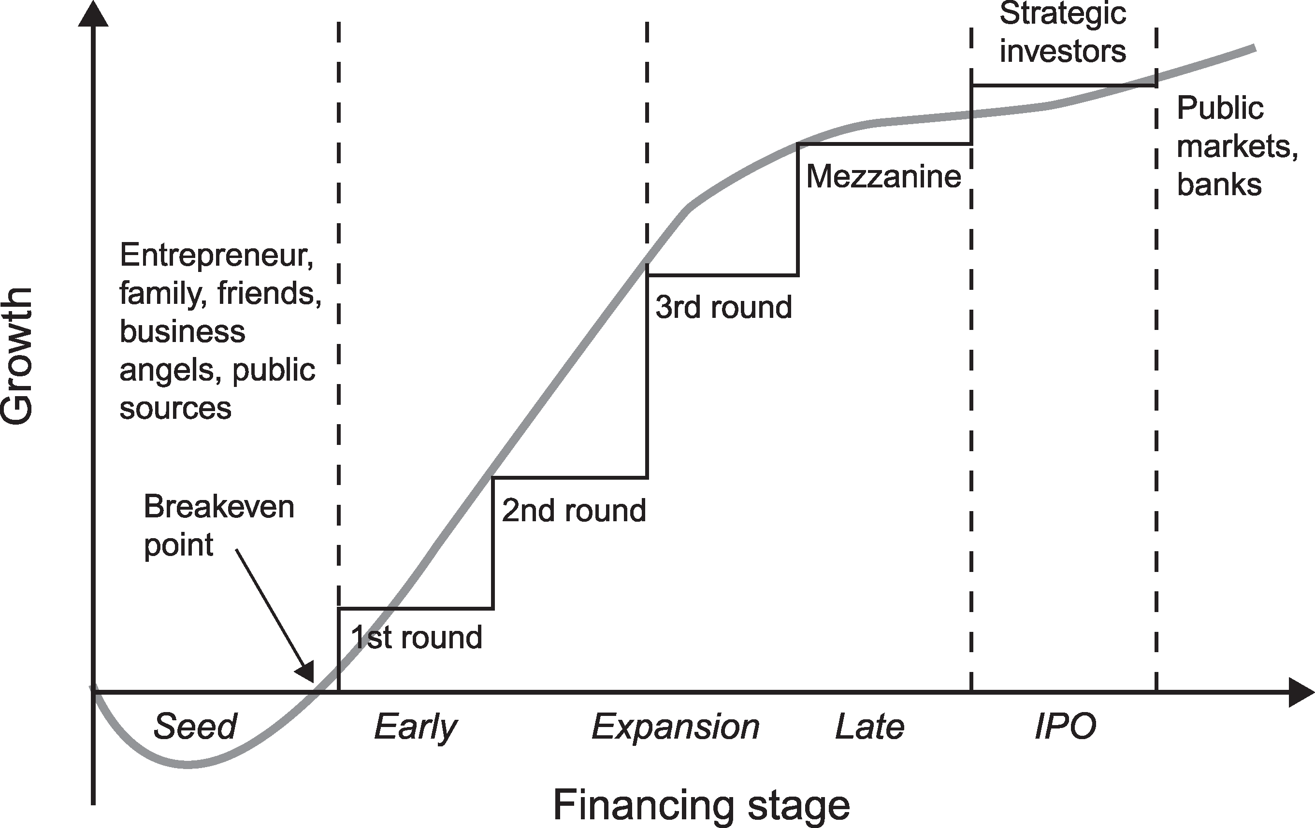  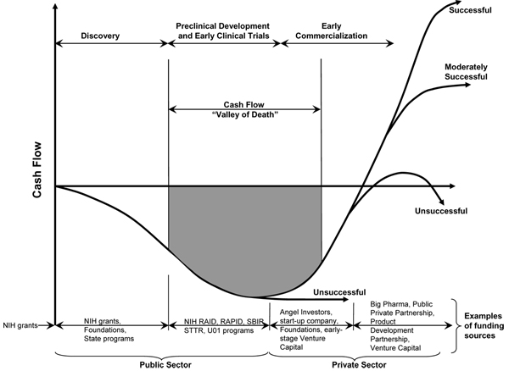  Plans for financing may be demonstrated through one or more of the following ways:  - Letter of commitment of funding  - Letter of intent or evidence of negotiations to provide funding, should the Phase II project be successful and the market need still exist  - Letter of support for the project and or some in-kind commitment, e.g. to test or evaluate the innovation  - Specific steps you are going to take to secure Phase III funding  Applicants are encouraged to seek commitment(s) of funds and/or resources from an investor or partner organization for commercialization of the product(s) or service(s) resulting from the SBIR/STTR grant. Phase III funding may be from any of a number of different sources.  F) Production and Marketing Plan  Describe how the production of your product/process/service will occur. Describe each step involved with taking your product to the market to sell which may include plans for licensing or internet sales.  4P’s  - Product  - Place (Channels of Distribution)  - Promotion (Communications Strategy)  - Pricing  Product: Should not be the thing itself but rather the total package of benefits obtained by the customer. After introducing a new product to the market there should be a process of Product Life Cycle Management where the company continually tries to learn more about consumers from their reactions to the introduced product.  Place: The marketing channel is the set of mechanisms or networks from which a company takes their product to market with its customers for a variety of tasks.  Promotion: Determining the appropriate ways to communicate with customers to foster awareness, knowledge about its features, interest in purchasing, likelihood of trying the product and or repeat purchasing.  Pricing: The value of the product can come from the customers perception or the actually product.  F) Revenue Stream  This section describes exactly how you plan to make money selling your product developed as the result of NIDA SBIR/STTR funding. A clearly laid out explanation on how you plan to generate a revenue stream may incorporate many tools such as revenue model estimations, charts, and graphs to display timeline goals. If a market is large and fragmented enough a potential option would be to partner with other companies with a proven history of generating revenue. Also take note of whether the company is a well-diversified company that has multiple products with few shared risk factors, or if the company is developing a single product where the risks may be more centralized.  Examples of revenue steam generation include but are not limited to:  - Manufacture and direct sales  - Sales through value added resellers or other distributors  - Joint venture  - Licensing  - Service  Sources:  Dolan, Robert. Note on Marketing Strategy. MS thesis. Harvard Business School, 1997. Boston, MA: privately published, 1997. Print.  Kolchinsky, Peter. "The Entrepreneur's Guide to a Biotech Startup." 4th edition. (2004): 1-96. Print. <http://www.evelexa.com>. |  | Key Ideas  The Commercialization Plan should illustrate your vision for the enterprise and how the proposed innovation fits into the future market.  This goal could be achieved through clearly articulating a compelling value proposition for your intended customer.  Keep in mind:  - Customers are sensitive to price  - Economies of scale are important  - An adequate production capacity should be available  - Threat of competition should be addressed  Points of Emphasis  - Commercial and societal benefits  - Competitive advantage over existing technology  Outline of Part A.  - Overall goal/objective  - The product, the problem it solves, and benefits  - History/past data suggesting a problem  - The advantages compared to competing products or services  - Recent advancements  - Commercial application  - Market potential, future markets, new research  - Non-commercial impact  - SBIR/STTR integration with business plan  Points of Emphasis  - Relevant commercialization capabilities of your team  - Product lines that show successful market implementation  Outline of Part B.  Company information including:  - Corporate objectives  - Core competencies  - Present size, products/services with significant sales  - History of previous Federal and non- Federal funding  - Regulatory experience  - How the company plans to develop from a small technology R&D business to a successful commercial entity  Points of Emphasis  - Know your market and market needs  - Identify main customer bases  - Know your competition  - Look into what similar competition has done and amount of the total market they are attracting  - Reiterate the need for the product and address your competitive advantage  - Consider if collaboration/ partnering is strategically smart for you and if so explain why  - Describe your market and sales strategy  Notes on Part C  Company analysis  - Corporate strengths and weakness need to be understood. Assessing product/company fit requires an understanding of the finances, R&D capacity, manufacturing capacity, and other assets of the firm.  Competitive Analysis:  - Identify both current and potential competitors. Competitor’s strengths and weaknesses must be understood to seek differentiating possibilities.  - It is very important that you understand and know the competition.  Collaborator Analysis:  - Two key collaborators are the retailers and suppliers. With respect to the trade, the firm must understand their cost structure; expectations about margins and allocations of task; support and training requirements; and the nature of their relationship with the firm’s competitors.  Context Analysis:  - Politics, regulation, law, and social norms are not fixed features of the marketing landscape, but factors to consider and monitor for signs of disruption  Points of Emphasis  - List current patents or describe how the company plans to protect the IP  Sources of Funding for Commercialization  SBIR/STTR firm itself; private investors or “angels”; venture capital firms; investment companies; joint ventures; R&D limited partnerships; strategic alliances; research contracts; sales of prototypes (built as part of this project); public offering; state finance programs; non SBIR-funded R&D or production commitments from a Federal agency with the intention that the results will be used by the United States government; or other industrial firms.  Two Key Questions:  - Which potential buyers should the company attempt to serve?  - How much customization should the firm offer in its programs, i.e. at which point on the market continuum will the firm construct plans:  - Mass Market – Market Segments – Market Niches – Individuals  Place  Channel Design  - Distribution via direct, indirect or both ways  - Proper design of contracts, good communication  Channel Management  - What policies and procedures will be used to have the necessary functions performed by the various parties?  Promotion  - Market - to whom is the communication to be addressed  - Mission - what is the objective of the communication  - Message - what are the specific points to be communicated  - Media - which vehicles will be used to convey the message  - Money - how much will be spent in the effort  - Measurement - how will impact be assessed after the campaign

